**NWAS supported equipment for Public Access Defibrillator**

**[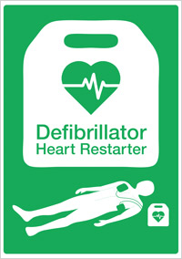](https://www.resus.org.uk/EasySiteWeb/GatewayLink.aspx?alId=21146)**

**NWAS support a number of defibrillator equipment across the North West, however whichever equipment you choose, please ensure that they fit within NWAS minimum standards guidelines (please see supporting document)**

**Choosing a Defibrillator**

**An Automated External defibrillator (AED) is designed to be used by the non-trained user, offering user prompts in a step-by- step way to assist the user ever if they have no first aid experience.**

**AEDs will only ever deliver a shock once the AED has analysed the casualty’s heart rhythm and determines that a shock is delivered.**

**AEDs are battery powered and hold their own charge, therefore docking stations and rechargeable batteries are not required. Each defibrillator has a different battery life and therefore this should be considered according to cost effectiveness and the environment it is to be placed.**

**Disposable single use pads are placed on the casualty’s chest where the AED will then determine the shock to be delivered. This is dependent on the heart’s rhythm. These pads must then be replaced. All AEDs offer a spare but we recommend the replenishment of these after use to ensure a spare set is always available.**

**AEDs offer different functions; some offer extensive user prompts including where to place the hands on the chest and how to carryout chest compressions, whilst others are more simplistic with the guidance and would be more suited to users with experience in CPR.**

**Others also have a metronome to ensure the rate of the compressions is maintained. Other features include feedback devices to provide user feedback ensure the right rhythm and depth is also maintained.**

**All AEDs can be used on a casualty from the age of 12 months old (though pad placement can vary) however all AEDs are suitable for children but separate paediatric pads are recommended for a child under the age of 8 years old. Some AEDs offer a paediatric mode which prevents the need for separate pads to be purchased.**

**Supported AEDs include:**

**[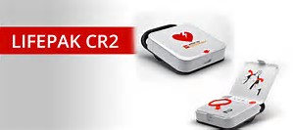](https://www.bing.com/images/search?view=detailV2&ccid=muGyVpWx&id=F954664D4B8C5A79FEF3F7C5E49B2EB277AD4422&thid=OIP.muGyVpWxpr0swyKbVmxsqgEsCF&q=LP+CR+2&simid=607999617911033465&selectedIndex=44)Physio Control CR 2- with WIFI**

**NWAS referral Price: £999 plus VAT**

* 5 Year battery (replacement only on expiry)
* 4 year electrodes (pads)
* Advanced user prompts including guidance on how to carryout CPR
* Metronome at a rate of 100-120
* Hands on Analysis
* Wifi capabilities to be viewed remotely by NWAS guardian portal
* Receive regular reminders to check device via manufacturer
* Paediatric Mode (no paediatric pads required)
* Rescue ready display to advise passed self- test and battery expiry
* 7 year warranty

**NWAS referral NON WIFI-**

* Semi auto is £799.00 plus delivery and VAT.
* Fully auto £888.00 plus delivery and VAT.

**CR 2 Bundle NWAS referral price £850 plus VAT**

* LPCR2 semi auto defibrillator- non wifi
* Hard shell carry case
* Rescue kit

**Extra Consumables**

Battery Replacement 147.05 plus VAT

Dual Electrode (Adult/child) £65.45

**\*Cabinet packages available with this defibrillator, please contact your NWAS contact for more information\***

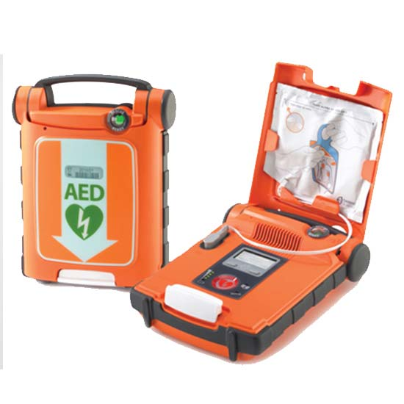**CARDIAC SCIENCE UK**

**Cardiac science G5 semi/fully automated defibrillator**

**NWAS Discounted Price: £800 plus VAT**

* 4-5 Year individual battery
* 2x Adult electrode
* 2 year electrode expiry
* [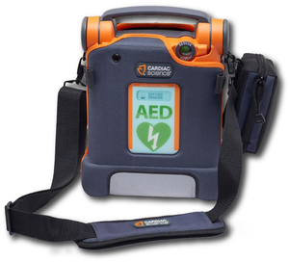](https://www.google.com/url?sa=i&rct=j&q=&esrc=s&source=images&cd=&ved=2ahUKEwiD1Mf2_tfkAhUOmRoKHX5FDmgQjRx6BAgBEAQ&url=https://aedteam.com/products/cardiac-science-powerheart%C2%AE-g5-aed&psig=AOvVaw3TjXhcn_tz8o3wGNVJDeFc&ust=1568814244597297)CPRD- feedback device available
* Advanced user prompts, including ‘stay calm’ ‘remove clothing’ ‘CPR instructions’
* Metronome
* Rescue ready display to advise passed self -test
* Audible alert if self-test not passed
* Paediatric pads available
* Easy post-use download
* 7 Year warranty
* Resus council UK Compliant

**Extra consumables**

G5 Accessories

XELAED001A/1B – G5 Adult Pads - £21.00 each plus delivery plus VAT

XELAED002A/2B – G5 Adult Pads with CPR Device - £60.00 each plus delivery plus VAT

XELAED003A/3B – G5 Paediatric Pads - £45.00 each plus delivery plus VAT

**\*cabinet packages available with this defibrillator- please contact your NWAS contact to discuss further\***

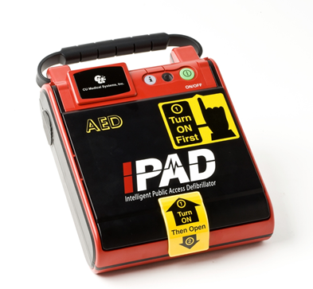**Wel medical IPAD Saver**

**NWAS Discount £625 plus VAT**

* 5 year battery
* 3 year electrode (pads) expiry
* Simple user prompts
* 5 year warranty
* Metronome as standard
* Resus council UK compliant
* Paediatric pads available

**Extra Consumables**

Battery- £130.00 plus VAT

Replacement pads- £29.95 plus VAT

Replacement paediatric pads- £60.00 plus VAT

[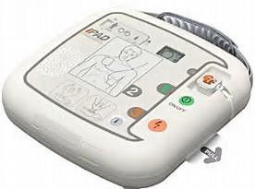](https://www.bing.com/images/search?view=detailV2&ccid=xkdvzh4q&id=79A612A4BF60923BAF379E372BCD3E0A358CC47A&thid=OIP.xkdvzh4qi5F6swpeisc8dAEsDq&q=ipad+sp1&simid=608013224400391041&selectedIndex=316)**IPAD SP1**

**NWAS discounted price £795 plus VAT**

* 5 year individual battery
* 3 year pad expiry
* Dual child and adult pads with paediatric mode
* 10 year warranty (registration mandatory)
* Metronome- optional according to preference
* Free carry case and x2 rescue kit
* Easy post use download

**Extra Consumables**

Battery- £130.00 plus VAT

Replacement pads- £29.95 plus VAT

**\*cabinet packages available with these defibrillators, please contact your NWAS contact for more information\***

**Defib Tech Life Line**

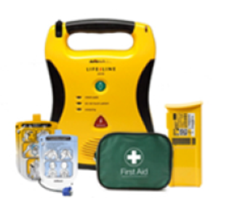**NWAS referral price £749 plus VAT**

* 8 year warranty
* 2 year pad/ electrode expiry
* 4 year battery
* Metronome
* Real time video
* Includes carry case
* Rescue kit

**Defib-Tech Life Line VIEW**

Provides visual video instruction as well as audible

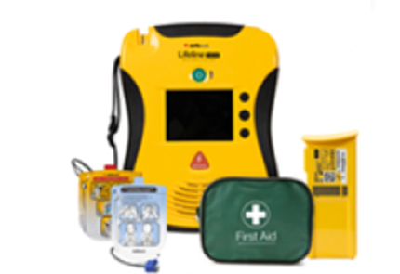**NWAS Referral £1099 plus VAT**

• 8 year warranty

• 2 year pad/ electrode expiry

• 4 year battery

• Metronome

• Real time video

• Includes carry case

• Rescue kit

**Extra Consumables**

Battery- from £165.00

Pads – from £39.00

**\*Cabinet packages available with these defibrillators, please contact your NWAS contact for more information\***

**Housing your AED**

**(becoming a Community Public Access defibrillator site)**

**[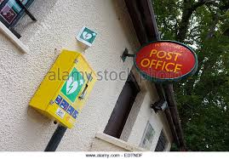](https://www.google.co.uk/imgres?imgurl=http://l7.alamy.com/zooms/d41e23b2c09741ae9808effbec2bcbf3/public-access-defibrillator-pad-on-wall-of-rural-post-office-in-scotland-edtndf.jpg&imgrefurl=http://www.alamy.com/stock-photo/public-defibrillator.html&docid=uTMsN_jbFXV5qM&tbnid=otrOf-kBdxnzvM:&vet=10ahUKEwj98vfn-I3WAhXhK8AKHfyfADs4ZBAzCBAoDjAO..i&w=640&h=445&bih=985&biw=1920&q=public%20access%20defibrillators&ved=0ahUKEwj98vfn-I3WAhXhK8AKHfyfADs4ZBAzCBAoDjAO&iact=mrc&uact=8)An AED is self-maintaining for battery life and is portable so it does not need to be placed on charge or plugged in, however if you wish to make your AED publically accessible 24 hours a day, it must be housed in a defibrillator cabinet fit for purpose.**

**NWAS recommend a heated and lit cabinet, installed by an electrician to the external wall at the height of approximately 1.3 meters from the floor. This is an optimum height for most users. It is important to ensure that the AED is housed under optimum temperature to ensure the AED is not affected by extreme temperatures which may affect the function of the AED.**

**NWAS hold minimum standards for placing a community public access defibrillator (CPAD) and NWAS must be informed before you place the equipment to ensure the equipment you choose meets suitability.**

**Cabinets to house an AED vary in size and price and the environment where the cabinet is to be fitted should be considered.**

**NWAS prefer locked cabinets to ensure the AED is only every taken for use when suitable and appropriate and the details of the location of the nearest AED resource would be given to a 999 caller when necessary. Unlocked cabinets can be more vulnerable in certain environments however NWAS do support unlocked cabinets providing they meet the CPAD minimum standards.**

**To discuss options to make your AED accessible as a CPAD please contact your AED lead or email at** [**www.chain.survival.nwas.nhs.uk**](http://www.chain.survival.nwas.nhs.uk)

**Current supported external defibrillator cabinets**

**(All cabinets are heated and lit)**

**[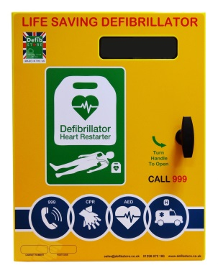](https://www.google.com/url?sa=i&rct=j&q=&esrc=s&source=images&cd=&ved=2ahUKEwiWksncgNjkAhUKfxoKHbaNCmIQjRx6BAgBEAQ&url=https://www.defibstore.co.uk/product/defib-store-3000-stainless-steel-cabinet-unlocked-heater-led-light/&psig=AOvVaw2AqKfoM9ATOheQbIu7ymcL&ust=1568814508813015)**

**DS1000 Cabinet- mild steel- from £419 plus VAT**

**Ds1000 Cabinet- Stainless steel- from £479 plus VAT**

**DS 2000 Cabinet- Mild steel- from £525 plus VAT**

**DS 3000 Cabinet- Stainless steel- from £595 plus VAT**

**[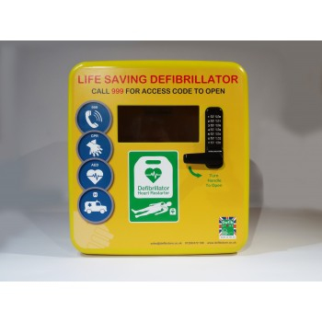](http://www.google.com/url?sa=i&rct=j&q=&esrc=s&source=images&cd=&ved=2ahUKEwi_5biygdjkAhXwyIUKHTt2AYgQjRx6BAgBEAQ&url=http://www.aed-defib-shop.co.uk/index.php?route%3Dproduct/product%26product_id%3D87&psig=AOvVaw2AqKfoM9ATOheQbIu7ymcL&ust=1568814508813015)**

**[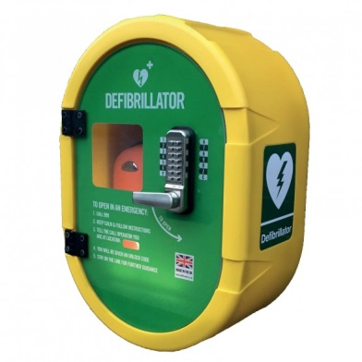](https://www.google.com/url?sa=i&rct=j&q=&esrc=s&source=images&cd=&ved=2ahUKEwiXp8zkgdjkAhVsx4UKHWEoCckQjRx6BAgBEAQ&url=https://www.medisave.co.uk/secure-external-defibrillator-cabinet-ds2-locked.html&psig=AOvVaw0FLtf8HMeHbwiNN2qvJRiF&ust=1568815090420117)DS4000 Cabinet- Polycarbonate- from £465.52 plus VAT**

**Defib Safe 2 Cabinet- Polycarbonate- £495.00 plus VAT**

**[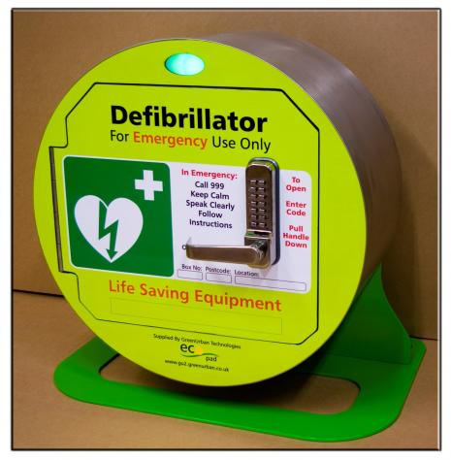](http://www.google.com/url?sa=i&rct=j&q=&esrc=s&source=images&cd=&cad=rja&uact=8&ved=2ahUKEwiqj-LOhdjkAhWTAmMBHeUCAg4QjRx6BAgBEAQ&url=http://www.amazonmedical.co.uk/products/detail/stainless-steel-defibrillator-cabinet&psig=AOvVaw2gmdd-glqNcgEub9mYaNcy&ust=1568815168422330)**

**Eco-Pad- Stainless steel- £735 plus VAT  
*Indoor cabinets are also available on request\***